
Flash To Pass

By: Timmy Draime, Robert Goode, Sarah Hall,

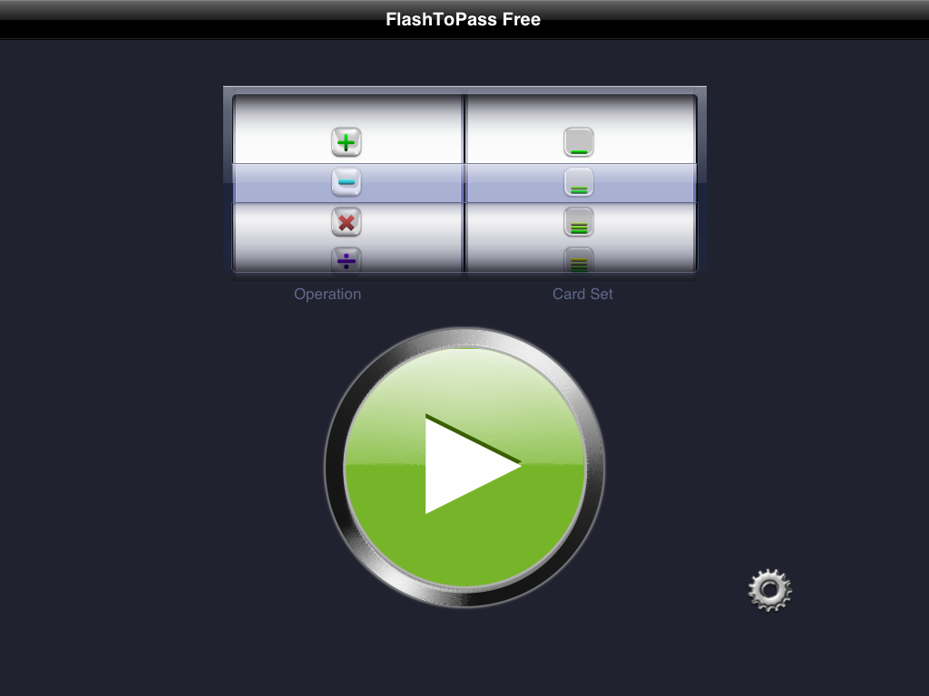
Flash to pass lite is an easy to use, elegant program designed to facilitate mastering the basic math facts learned in elementary school.

Getting started-
Click on the app and it will bring you to the home page.

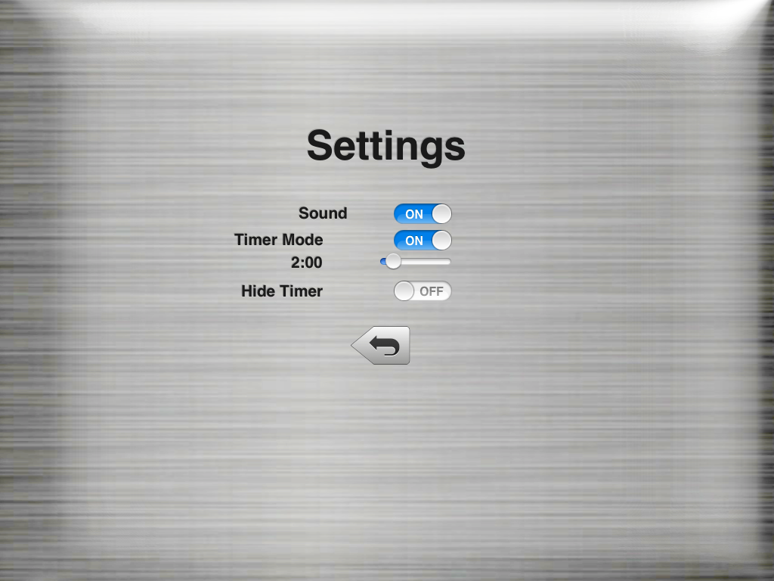
From there you can go to settings and change the amount of time given from the start of the game to the end.

Then you go back to the main menu select your operation then select your level and press the big play button to begin.


