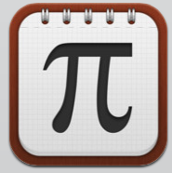
iMathematics!
WHAT IT IS
Its always difficult to have everything you need for math in one spot. This app features tools that can help you in that subject by giving examples on how to do things, definitions to words you don't know, function when you forget, and it even helps with calculations.
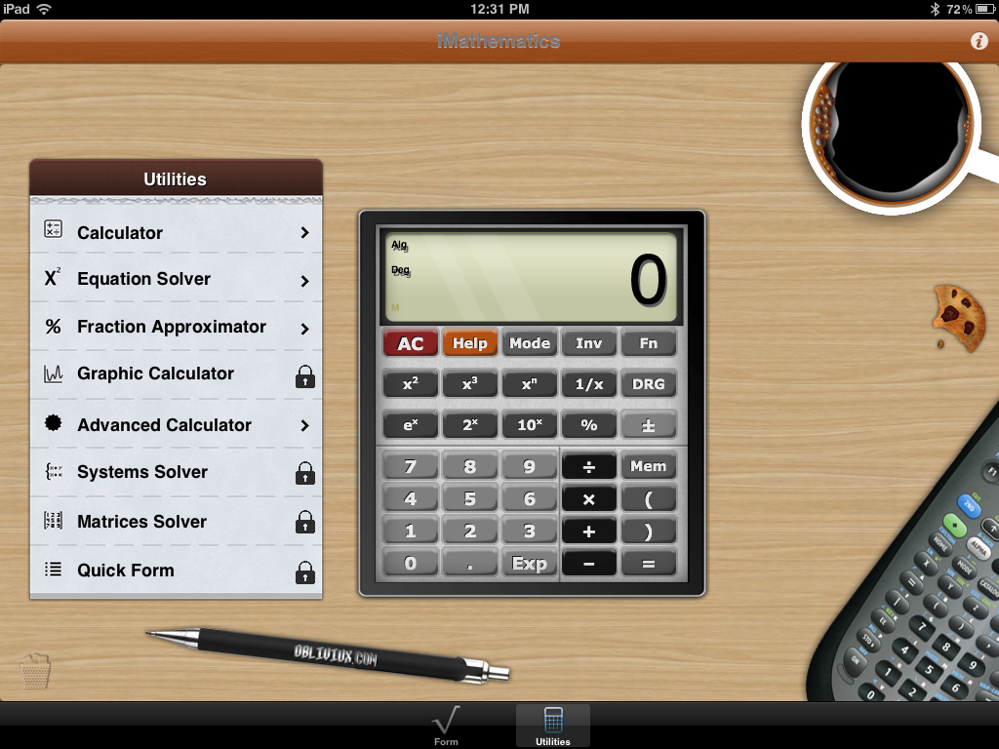

There are eight different subjects iMathematics can assist you in. It has four different calculators you can use. And you can also write notes or do work along the side.
HOW TO
Download the free app from the app store.
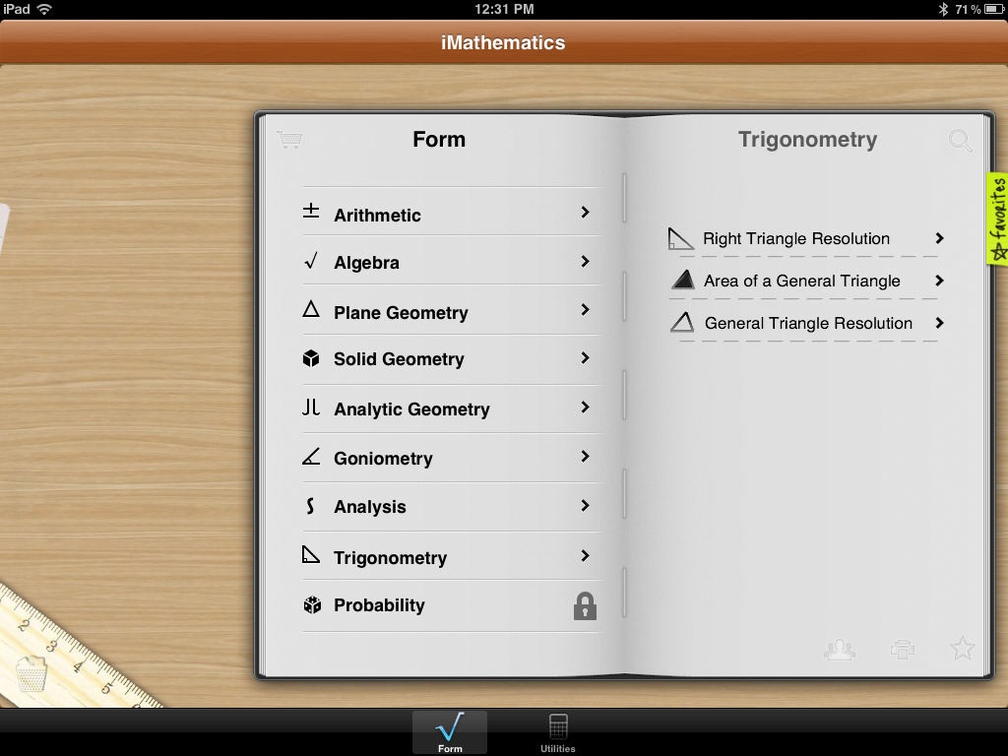

Choose whichever subject or area you need help in. And thats it! All this useful and helpful information pops up for you. Need a calculator instead?Just hit the UTILITIES button the bottom of the page and it'll take you there. While reading or calculating, you can even do your work right on that page. Just take your finger or stylus and start writing. Its never been easier.
P225
This is such a handy app! No need for everyone to get up, get a text book, get a calculator. We're using technology to help us learn and use or resources as an advantage.

