Educational Apps and it's Uses

By: Vattey Duong, Brooke Hall, Tal Kim, Mackenzie Newton and Devyn Richmond

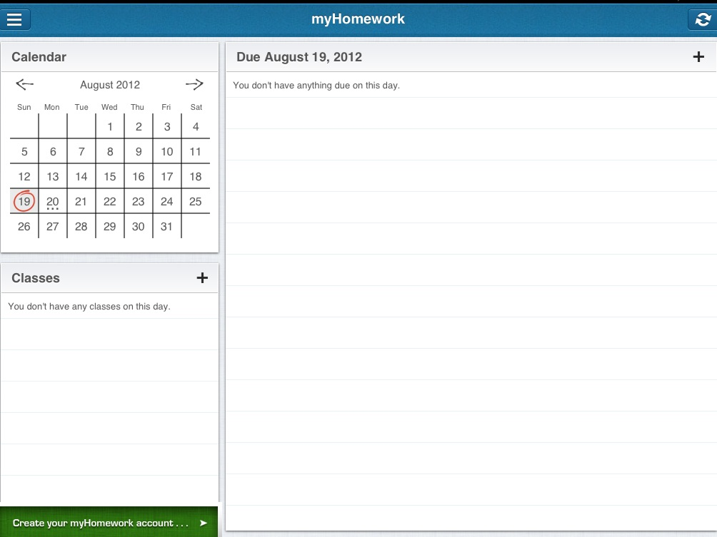

My classmates and I have came across two great apps in the App Store named myHomework and Textbooks. Both apps are school related and offers cool features such as multi-task, easy to work programs, usage not only inside, but outside of school, and liability for wherever you go.

As you can see, myHomework allows high quality organization on the top left, reminders of classes on the bottom left, and reminders of assignments due all in easy places to find, touch, and edit.

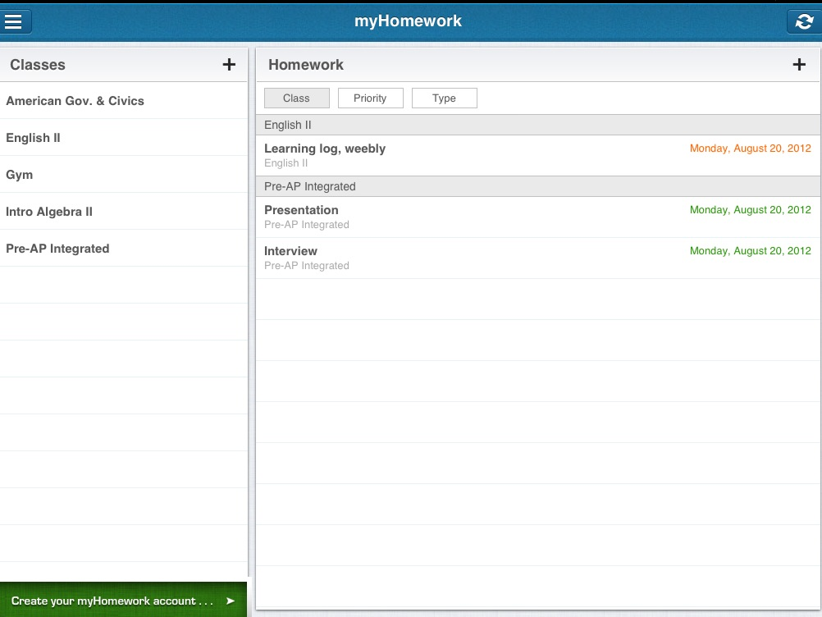
You may also keep track of all of your completed, late, and upcoming homework.

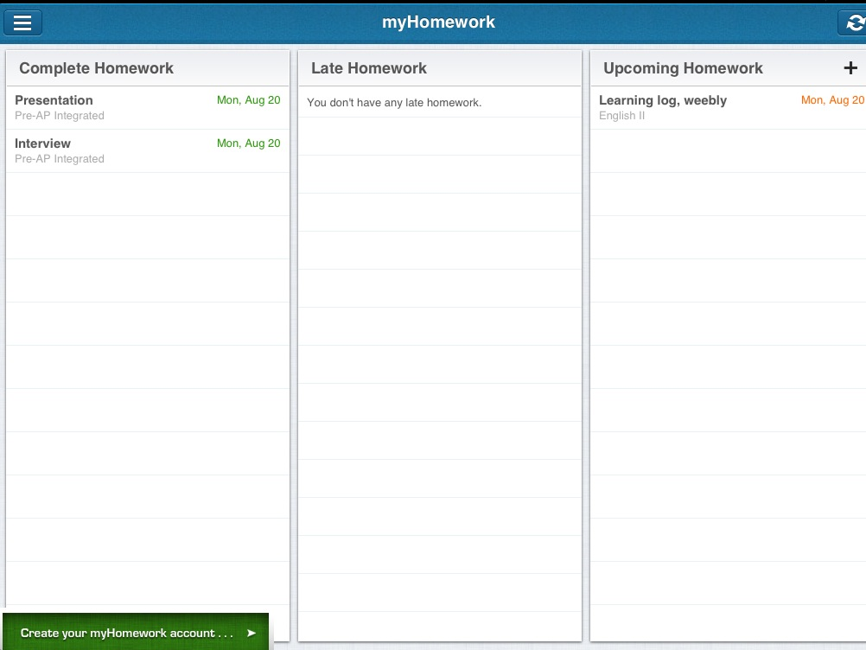


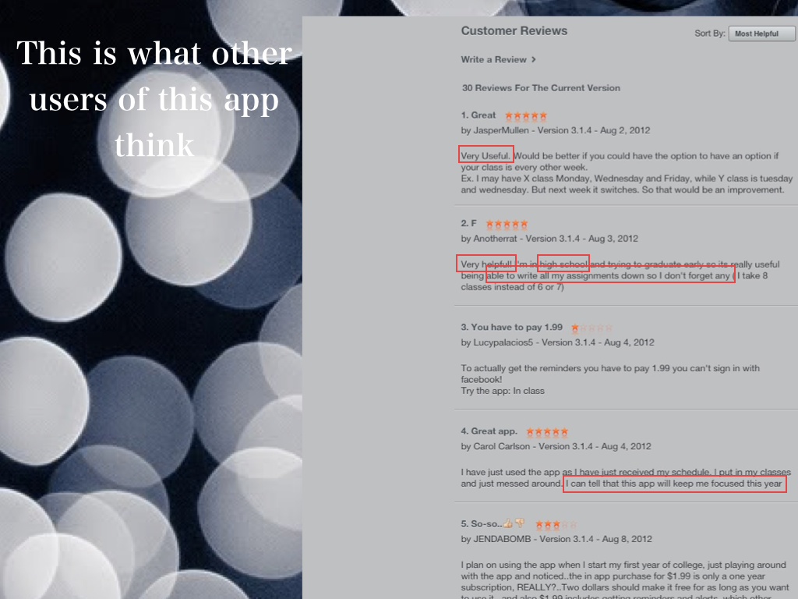
Even better, you're able to view everything at once, which allows you to multitask.

If anything, myHomework has gotten great overall reviews that prove for their fantastic and useful app. May I also remind you it's FREE?

Now I would love to tell you about our second discovery while searching the App Store; Textbooks.
Textbooks allows students, such as ourselves, carry around our textbooks to wherever we please without it being so overweight. It's all stored into an electronic device that is thin and easy to carry.

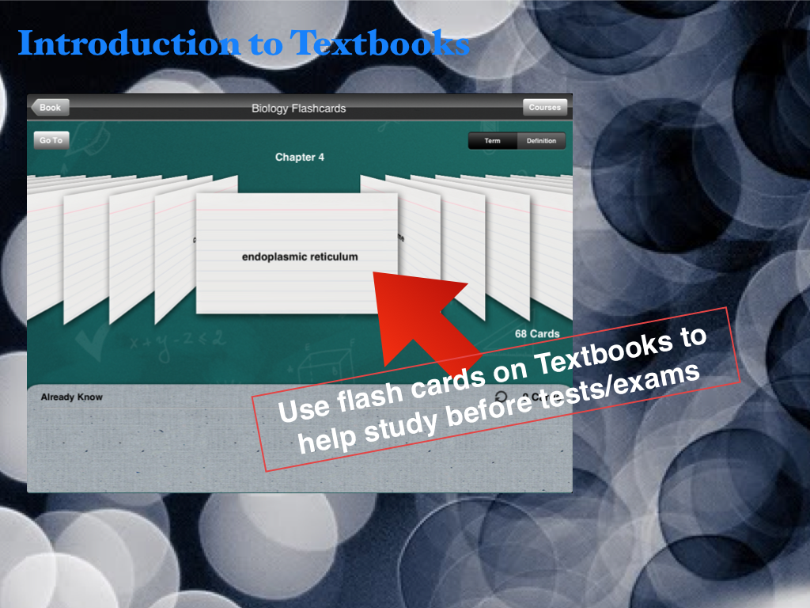

As you see here, Textbooks have great features such as flash cards. This could really come in handy for students who need to study or review over materials on a specific subject.
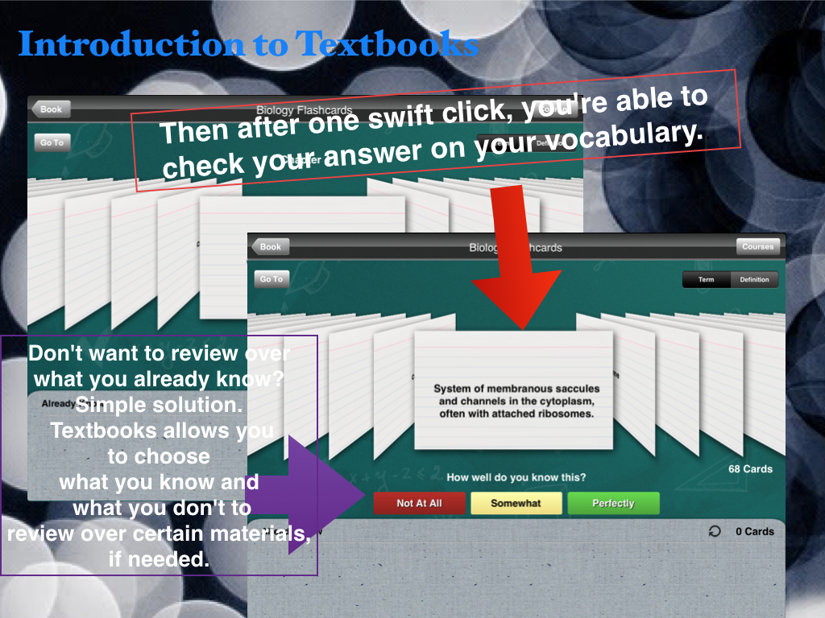
Not only that, Textbooks gives you an option to check your answers, which is another great reason to use for studying. This app also holds How well do you know this? option that you can choose from from three answers that helps decided to go over various flash cards over again and/or to apply that you know the information and move on.
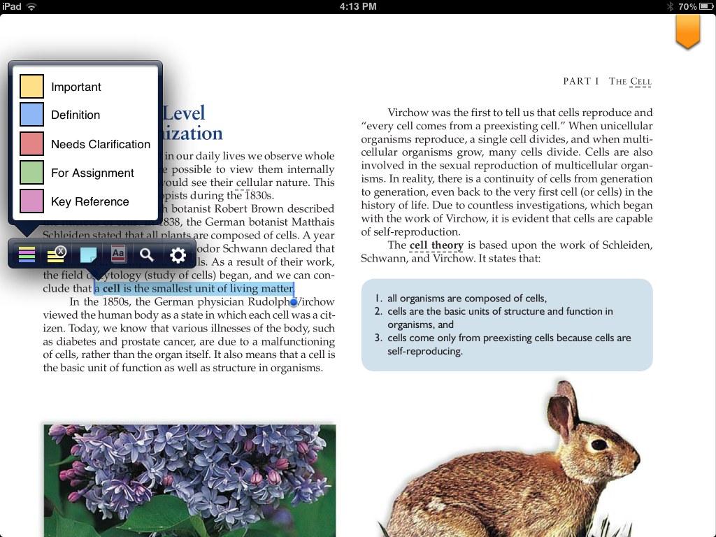

Not only is Textbooks easy to use with alone studying, but perfect for users who prefer to stay a bit more organized. What you see above is the option to highlight fragments of a paragraph. What makes this super neat is the color-coding feature that comes along with it.

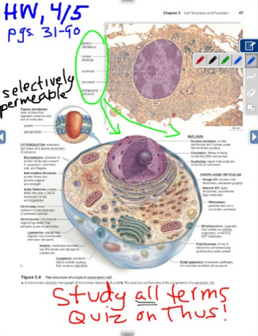
And to top it all off, you're able to write on your textbooks! Write down reminders on pages so you won't forget later on in the day with colorful markers that sticks out and really catches your eyes.

We all know real textbooks aren't the cheapest things around, so why not download this FREE app and buy textbooks on there? It's in a easy place to find and you'll never have sore shoulders again from the heavy weight in your backpack.

