RSInfo 9 REMEDIATION **Carefully annotate the text in support of your responses.
Close reading of primary source documents

President Abraham Lincoln’s Speech
The Gettysburg Address, 1863
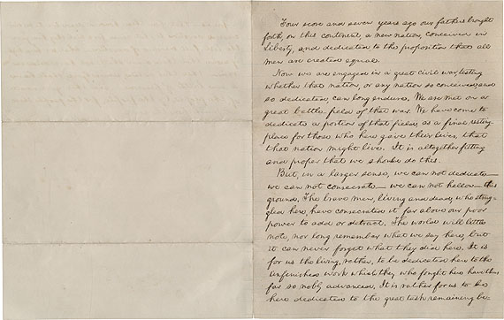
*Cornell University Library

Four score and seven years ago our fathers brought forth on this continent, a new nation, conceived in Liberty, and dedicated to the proposition that all men are created equal.
Now we are engaged in a great civil war, testing whether that nation, or any nation so conceived and so dedicated, can long endure. We are met on a great battlefield of that war. We have come to dedicate a portion of that field, as a final resting place for those who here gave their lives that that nation might live. It is altogether fitting and proper that we should do this.
But, in a larger sense, we can not dedicate—we can not consecrate--we can hallow—this ground. The brave men, living and dead, who struggled here, have consecrated it, far above our poor power to add or detract. The world will little note, nor long remember what we say here, but it can never forget what they did here. It is for us the living, rather, to be dedicated here to the unfinished work which they who fought here have thus far so nobly advanced. It is rather for us to be here dedicated to the great task remaining before us—that from these honored dead we take increased devotion—that we here highly resolve that these dead shall not have died in vain--that this nation, under God, shall have a new birth of freedom—and that government of the people, by the people, for the people, shall not perish from the earth.
Close reading of primary source documents

Read the “Gettysburg Address”
Paraphrase paragraph 1

Paraphrase paragraph 2

Reread the text and use the guiding questions below to self-assess your close reading and understanding of Lincoln’s message:
- According to Lincoln, what made this nation new?
- What is being tested by this war?
- What if Lincoln had used the verb “start” instead of “conceive?” (line 1)
- How does Lincoln establish what is at stake in this war in the first two sentences of the Gettysburg Address?
- What did those who fought at Gettysburg do that those who have gathered cannot?
- What is the unfinished work that those listening to the speech are asked to achieve?
- How does Lincoln use the idea of “unfinished work” to assign responsibility to his listeners?

Growing Vocabularies:
- Record the contextual meaning of dedicate as it is used in each instance and discuss your meanings with a partner.
Dedicated, line 2
Dedicated, line 4
Dedicate, line 4
Dedicate, line 7
Dedicated, line 10
Dedicated, line 11

Vocabulary response:
In paragraph form trace the accumulated meaning of the word “dedicate” through the text—how does the word because more powerful as Lincoln’s speech continues?

Responding to the prompt: Lincoln shifts the focus and purpose of his “Gettysburg Address” at the end of the second paragraph. Why does he do this—what reasons does he give for the change? What does Lincoln think is the task left to those listening to his speech? What relevance does Lincoln’s message have in today’s political climate?
Thesis statement:

Evidence 1—

Evidence 2—

Evidence 3—

Score:twenty
Civil war: a war between citizens of the same country
Consecrate: declare a place sacred
In vain: without accomplishing anything

